KIBAKWE SECONDARY SCHOOL
FORM TWO HOLIDAY PACKAGE 2020

ENGLISH
BY ELIASI KASHONELE INDEX NO

Instructions :
- This paper consists of sections A, B, C and D.
- Answer all questions.

SECTION A: COMPREHENSION (25 marks)
- Read careful the passage below and then answer the questions that follow.
Many diseases are found in all parts of the world but some are more common in particular areas. In East Africa, two common diseases are malaria and diarrhea.
Malaria is a disease spread by mosquito bite. When you get malaria, you are likely to feel sick. The symptoms of malaria include high fever and headache. The high fever can make you feel very cold or very hot. Often you vomit when you have malaria.
One way of protecting yourself from malaria is to destroy places where mosquitoes breed. Another way is to sleep under a mosquito net if you are staying or living in an area that has many mosquitoes.
Diarrhea is another common disease in East Africa. It is spread by dirty food or water. When you have diarrhea, you pass very loose stools. You have a high fever and can have severe stomachache. Vomiting also often accompanies diarrhea.
To prefect yourself against diarrhea, you should observe hygiene. This includes forming a habit of washing your hands after visiting the toilet and before eating. You should cover food so that flies do not land on it. Again, you should ensure that the water you drink is boiled or has been purified in some way.
Questions
- Choose the most correct answer and write it is letter in the space provided,
- One of the good ways of preventing malaria is:-

- Improving personal hygiene
- Sleeping under a mosquito net.
- High fever and vomiting.
- Avoiding dirty water or food.

- Among the symptoms of malaria is :-

- Severe stomachache
- Eating too much
- High fever
- Passing very loose stools

- Which of the following may be a symptom in both malaria and diarrhea:-

- Gaining food appetite
- Vomiting
- Headache
- Feeling cold only

- Why do we need to cover our food?
- To protect mosquitoes from landing on it
- To kill the bacteria which cause diarrhea
- To hide if from being eaten by insects
- To protect flies from landing on it

- Why do we boil our drinking water?
- To kill the mosquitoes responsible for transmitting malaria
- Reduce coldness of water before drinking
- Killing the germs that are responsible for diarrhea
- Threatening the germs causing diarrhea

- Write TRUE or FALSE
- Vomiting and headache are symptoms of malaria __________________
- Washing your hands after visiting the toilet may prevent the transmission of malaria________
- Purifying water is useful in controlling diarrhea _______________
- There are only two diseases which are found in East Africa____________
- The best title of the passage may be symptoms and prevention of HIV/AIDS__________

- Question: Summarize the following passage in three sentences.
Human population is an alarmingly growing. Population expected to raise concern over food security, places to establish new settlements and unemployment rate. However WHO and UNESCO have suggested some steps to lessen the growing threat. Family planning methods are considered to be working unfortunately people in African and Asia reject those methods due to their after math effects.

SECTION B: (LANGUAGE USE) 20MARKS
- Matching items
Column A | Column B
- It might rain | - Despite his laziness
- Despite the hot sun | - Yet they expected wonders
- He succeeded | - They did not stop digging canal
- The girl followed what was being said | - Despite her hearing impairment
- Temperature was high | - Although the sky is clear

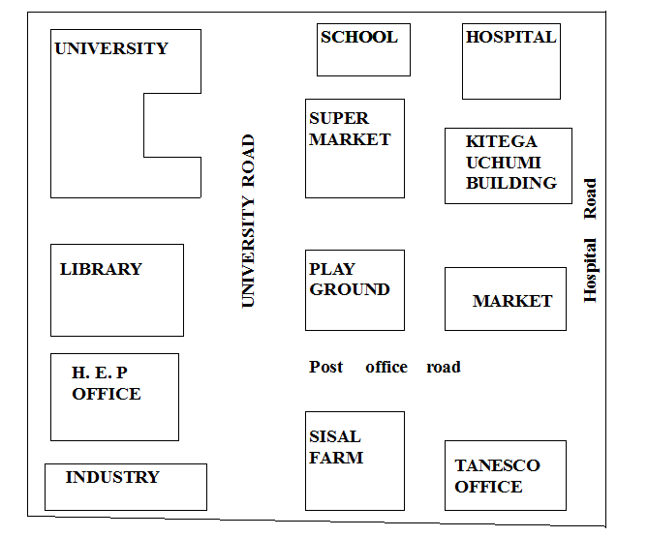
- Study the map below and provide the correct directions using a compass.

- The library is in the __________________________of the playground.
- The playground is in the ______________________of the market.
- The TANESCO building is in the _________________of the playground.
- The sisal farm is in the _______________________of the playground.
- The ___________________________is in the North East of the playground.

- Read the information and fill the form below in capital letters.
Mustapha is a resident of Mtwara. He was born on 15th September 1991, at Singida. His father Mr. Fahad operates patients from the municipal hospital while his mother always buys and sales commodities from Moshi. He is the forth in the family of seven children. His mother Mrs. Leila was born the day when Tanganyika got her independence from the British. And Mustapha’s father was born just five years before Tanganyika independence.
He is at Morogoro University studying Medicine but he wants to sell medicine in his own pharmacy after graduating at the end of next academic year 2014 – 2015.
Personal Information
- Name ………………………………………………………… Gender ……………………………Age………………………
- Position in the family ………………………………………………………………………………………………………….
- Place of Residence ………………………………………………………………………………………………………………
- Place of Birth ………………………………………………………………………………………………………………………
- Course of study ……………………………………………………………………………………………………………………
- University ……………………………………………………………………………………………………………………………
Parents Information
- Father’s Name ………………………………………………………………………… Age …………………………………
- Father’s occupation ……………………………………………………………………………………………………………
- Mother’s Name ………………………………………………………………………. Age …………………………………
- Mother’s occupation ……………………………………………………………………………………………………………

- Complete the following story by using appropriate verb from
My name is Juma. I _____________(be) 13 years old. I _____________(go) to the market yesterday, to __________ (buy) some fruits. On the way to the market I __________(see) many people. Now, I am ____________(walk) to school.

SECTION C
- Complete the sentences with the correct preposition from the list provided; you can use the words more than once.
- He plays guitar ___________his own pleasure.
- That’s a rare set __________ book.
- The trouble ___________photography is that it is expensive.
- I got tired ___________building model ship.
- It takes my mind ___________my work.
With, of, at, by, for, off, in, to

- Rewrite the following sentences by using the instructions given.
- He is very fat. He can not run. (use too …………………. to).
- Juma ate his supper. He went to sleep (Join the two sentences into one).
- It was raining. We enjoyed the wedding. (Use Although).
- I study hard so as to pass the exams. (Use in order to).
- She will be teaching him how to read and write. (Change it into simple present tense).

- Use the following articles to fill in the blanks
a, the, an
- I saw ___________man who came here yesterday.
- It may take _____________hour to complete this task.
- ____________________woman was wearing a red dress.
- __________________lion is a dangerous animal.
- __________________pen is used for writing.

- Read the information below and answer the following questions.
Shukurani married a wife called Shukuru,.Tumsifu and Bakari are their sons. Their daughters are Suna and Neema. Tumsifu got married to Tumaini and Bakari got married to Bahati. Bakari and Bahati have got two children, Yusuph and Mariam. Neema got married to Samir their children are Yasir and Yasmin.
Questions
- Who is Shukuran’s wife?
- What are names of Shukuran and Shukuru’s sons?
- What are the names of Shukuran and Shukuru’s daughters?
- What does Bakari call Shukuran?
- What does Bahati call Shukuran?
- Mariam calls Neema________________?

- Yasmin calls Samir ___________________?
- What does Bahati calls Yasir?
- Bakari calls Yasmin?
- What does tumain calls Bakari?

SECTION D: READING PROGRAMMERS (15 marks)
- Read the poem below and answer the questions that follow:-
You came like a thief,
You came like a snake,
A snake in the grass!
Oh! Why were you ever created?

Like lightning you strike people.
Like electricity you shock people
The young and the old, the poor and the rich
Oh! Why were you ever created?

You have left us fatherless, motherless, and childless
Oh! Ladies and gentlemen, gather our strength
Wage a big war against the enemy
Oh! HIV, why have you ever created?
Questions
- Who is “You” in the poem?
- Suggest two ways on how we can avoid problem caused by “you”.
- In stanza three what problem does “you” cause?
- How many stanzas are in the poem?
- How many verses are in each stanza?
- Is the poem relevant to the situation we are living in?

- Choose one class reader you have read from the list below and write a report using the following questions as a guide.
Questions
- What is the title of the book?
- What is the book you have chosen about?
- Who is the author of the book?
- Who is the main character?
- Which character did you like most? Give 1 reason.
- Which character did you dislike most? Why? Give 1 reason.
What have you learn from the book? Give two lessons.

